

**МИНОБРНАУКИ РОССИИ**

**Федеральное государственное бюджетное образовательное учреждение**

**Высшего образования**

**«Московский государственный технологический университет «СТАНКИН»**

**(ФГБОУ ВО МГТУ «СТАНКИН»)**

|  |  |
| --- | --- |
| ***ФАКУЛЬТЕТ***  Информационных систем | **Кафедра**  информационных систем |

**Отчет по лабораторной работе №6**

|  |  |  |
| --- | --- | --- |
| **Студент** группа ИДБ–18-07 |  | **Чернат Н.Н.** |
|  | Подпись |  |
| Руководитель преподаватель |  | **Сосенушкин С.Е.** |
|  | подпись |  |

Москва 2021 г.

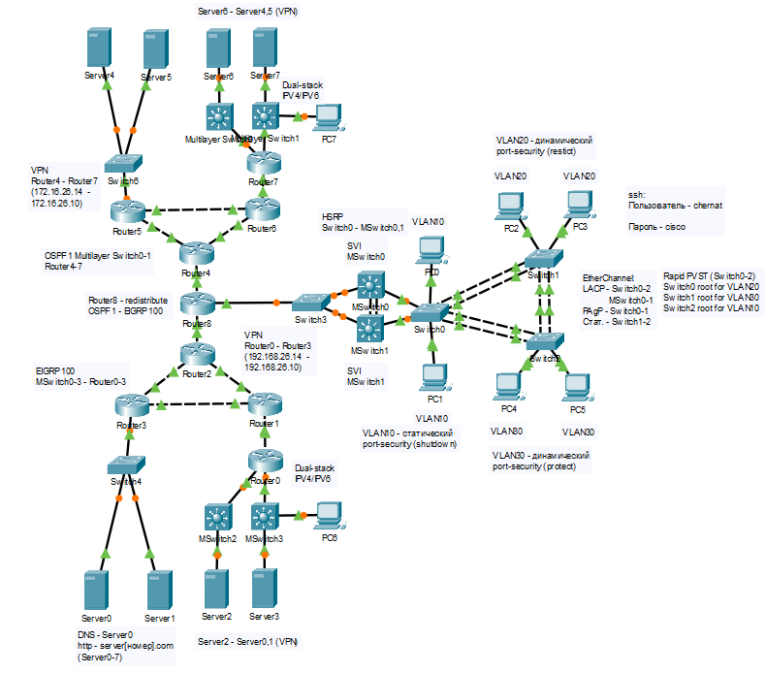

Рис. . Схема сети

Таблица . Конфигурация устройств

|  |  |  |  |  |
| --- | --- | --- | --- | --- |
| Устройство | Интерфейс | IP-адрес\IPv6-адрес | Маска подсети | Шлюз по умолчанию |
| Router0 | F0/0 | 40.26.4.1 | 255.255.255.0 | - |
| 2001:26:4::1 | /64 | - |
| F0/1 | 192.168.26.14 | 255.255.255.252 | - |
| E0/0/0 | 40.26.3.1 | 255.255.255.248 | - |
| 2001:26:3::1 | /64 | - |
| Router1 | F0/0 | 192.168.26.13 | 255.255.255.252 | - |
| F0/1 | 192.168.26.6 | 255.255.255.252 | - |
| E0/0/0 | 192.168.26.9 | 255.255.255.252 | - |
| Router2 | F0/0 | 192.168.26.41 | 255.255.255.252 | - |
| E0/0/0 | 192.168.26.5 | 255.255.255.252 | - |
| E0/1/0 | 192.168.26.1 | 255.255.255.252 | - |
| Router3 | F0/0 | 192.168.26.33 | 255.255.255.248 | - |
| E0/0/0 | 192.168.26.10 | 255.255.255.252 | - |
| E0/1/0 | 192.168.26.2 | 255.255.255.252 | - |
| Router4 | F0/0 | 172.16.26.41 | 255.255.255.252 |  |
| E0/0/0 | 172.16.26.5 | 255.255.255.252 | - |
| E0/1/0 | 172.16.26.1 | 255.255.255.252 | - |
| Router5 | F0/0 | 172.16.26.33 | 255.255.255.248 | - |
| E0/0/0 | 172.16.26.10 | 255.255.255.252 | - |
| E0/1/0 | 172.16.26.2 | 255.255.255.252 | - |
| Router6 | F0/0 | 172.16.26.13 | 255.255.255.252 | - |
| F0/1 | 172.16.26.6 | 255.255.255.252 | - |
| E0/0/0 | 172.16.26.9 | 255.255.255.252 | - |
| Router7 | F0/0 | 60.26.3.1 | 255.255.255.248 |  |
| 2001:52:3::1 | /64 |  |
| F0/1 | 60.26.4.1 | 255.255.255.0 |  |
| 2001:52:4::1 | /64 |  |
| E0/0/0 | 172.16.26.14 | 255.255.255.252 |  |
| Router8 | F0/0 | 172.16.26.42 | 255.255.255.252 |  |
| F0/1 | 192.168.26.42 | 255.255.255.252 |  |
| E0/0/0 | 192.168.25.7 | 255.255.255.0 |  |
| MSwitch0 | Vlan1 | 192.168.25.6 | 255.255.255.0 | - |
| Vlan10 | 10.26.1.3 | 255.255.255.0 | - |
| Vlan20 | 20.26.2.3 | 255.255.255.0 | - |
| Vlan30 | 30.26.3.3 | 255.255.255.0 | - |
| MSwitch1 | Vlan1 | 192.168.25.5 | 255.255.255.0 | - |
| Vlan10 | 10.26.1.2 | 255.255.255.0 | - |
| Vlan20 | 20.26.2.2 | 255.255.255.0 | - |
| Vlan30 | 30.26.3.2 | 255.255.255.0 | - |
| MultilayerSwitch0 | Vlan1 | 60.26.3.3 | 255.255.255.248 | - |
| MultilayerSwitch1 | Vlan1 | 60.26.4.2 | 255.255.255.0 | - |
| MSwitch2 | Vlan1 | 40.26.3.3 | 255.255.255.248 | - |
| MSwitch3 | Vlan1 | 40.26.4.2 | 255.255.255.0 | - |
| Switch0 | Vlan1 | 192.168.26.2 | 255.255.255.0 | 192.168.25.1 |
| Switch1 | Vlan1 | 192.168.26.3 | 255.255.255.0 | 192.168.25.1 |
| Switch2 | Vlan1 | 192.168.26.4 | 255.255.255.0 | 192.168.25.1 |
| Switch3 | Vlan1 | 192.168.26.8 | 255.255.255.0 | 192.168.25.7 |
| Switch4 | Vlan1 | 192.168.26.36 | 255.255.255.248 | 192.168.26.33 |
| Switch6 | Vlan1 | 172.16.26.36 | 255.255.255.248 | 172.16.26.33 |
| Server0 | NIC | 192.168.26.35 | 255.255.255.248 | 192.168.26.33 |
| Server1 | NIC | 192.168.26.34 | 255.255.255.248 | 192.168.26.33 |
| Server2 | NIC | 40.26.3.2 | 255.255.255.248 | 40.26.3.1 |
| 2001:26:3::2 | /64 | 2001:26:3::1 |
| Server3 | NIC | 40.26.4.254 | 255.255.255.0 | 40.26.4.1 |
| 2001:26:4::2 | /64 | 2001:26:4::1 |
| Server4 | NIC | 172.16.26.35 | 255.255.255.248 | 172.16.26.33 |
| Server5 | NIC | 172.16.26.34 | 255.255.255.248 | 172.16.26.33 |
| Server6 | NIC | 60.26.3.2 | 255.255.255.248 | 60.26.3.1 |
| 2001:52:3::2 | /64 | 2001:52:3::1 |
| Server7 | NIC | 60.26.4.254 | 255.255.255.0 | 60.26.4.1 |
| 2001:52:4::2 | /64 | 2001:52:4::1 |
| PC0 | NIC | 10.26.1.254 | 255.255.255.0 | 10.26.1.1 |
| PC1 | NIC | 10.26.1.253 | 255.255.255.0 | 10.26.1.1 |
| PC2 | NIC | 20.26.2.254 | 255.255.255.0 | 20.26.2.1 |
| PC3 | NIC | 20.26.2.253 | 255.255.255.0 | 20.26.2.1 |
| PC4 | NIC | 30.26.3.254 | 255.255.255.0 | 30.26.3.1 |
| PC5 | NIC | 30.26.3.253 | 255.255.255.0 | 30.26.3.1 |
| PC6 | NIC | 40.26.4.253 | 255.255.255.0 | 40.26.4.1 |
| 2001:26:4::3 | /64 | 2001:26:4::1 |
| PC7 | NIC | 60.26.4.253 | 255.255.255.0 | 60.26.4.1 |
| 2001:52:4::3 | /64 | 2001:52:4::1 |

Сеть использует технологии и протоколы: port-security, VLAN, PVST, EtherChannel, EIGRP, OSPF, DNS, ssh, веб-сервера, SVI, HSRP, VPN и IPv6.

Часть роутеров настроено по протоколу EIGRP, а другая часть по OSPF. Все это пересекается в Router8, где проходит редистрибуция.